**Handling Cathy’s Unique Body:**

**Things That Hurt and Things That Help**

1. Remember that what **LOOKS RIGHT** to you may be **WRONG** for me.
2. **Protect my airway** by watching the position of my head and body:

* **NEVER place a pillow under my head.** This will strangle me.
* **USE EXTREME CAUTION in turning my head**, as this narrows my airway. My head's natural position is 45° to the right.
* **I breathe easier** if you move (**NOT TURN!**) my head away from my right shoulder. Push my temple or under my head to slide it over.
* **IF I AM REALLY HAVING TROUBLE BREATHING,** it can help to place something about 1” thick (i.e.: folded towel) under my shoulders to tip my head back. It also reduces the feeling that I can’t breathe.
* I am safest **LYING ON MY BACK.** (Tips on preventing pressure sores come later in this document. For now, focus on **BREATHING**)
* Unless you are tube-feeding me, **KEEP MY BED FLAT.** Elevating the head makes me congested, and gravity makes it hard to clear.

1. **Other airway issues:**

* **NO DEEP SUCTIONING.** I have **REACTIVE AIRWAYS** which close when they feel the tube. **ASSISTED COUGHING** is more effective. My assistants and friends know the best way to do it.
* Breathing support:
* **INTUBATION IS CHALLENGING** because my mouth does not open much and my airway is twisted.
* If at all possible, use local anesthetic or conscious sedation.
* If not possible, **NASAL FIBER OPTIC INTUBATION** is best.
* I use a BIPAP support my breathing when I am asleep.
* I have had serious breathing problems because my hospital room was so dry my throat filled up with thick mucus. Adding saline solution to my nebulizer treatments via mask solved the problem.

1. **I have contractures EVERYWHERE. Please be careful.**

* **SHOULDERS** - I cannot raise my arms or rotate outward. Safest position is with hands on my belly.
* **ELBOWS** - do not straighten or bend too much. Notice the resistance.
* **HANDS** **AND FINGERS** - don’t let them get crushed or bent back. Be especially careful moving sheets or johnny because my fingers get caught and bent in bad ways.
* **LEFT HIP** - dislocated, so it turns in a lot. Turning it out feels weird. Lifting it gives a little more room than moving it outward.
* **RIGHT HIP** - more flexible than the left, but still be careful.
* **KNEES** - do not bend or straighten too much. 90° is too bent. Do not sit me up too far with my legs straight, as this will pull my hamstrings.
* **ANKLES** - basically frozen.
* **TOES** - delicate. Please be careful putting on socks that all toes are inside the sock and are going in the same direction.
* **I don’t like people to touch my feet.**
* **PLEASE SEE PHOTOS AT THE END.**

1. **Moving and positioning**

* **Moving me from stretcher, to table, to bed** - sliding sideways is not too bad. Just keep me as straight as you can.
* **Lying on my back** - is my safest and most comfortable position. Place a folded towel by my temple and push gently to tilt my head left, but **do not turn it!** Put my cup next to my mouth and secure it with the beanbag. My hands are happiest when placed on my last rib. A pillow under my knees is comfortable, and prevents pressure sores on my heels.
* **Rolling to the LEFT is much easier than to the RIGHT.**
* **Sitting up** is okay as long as my trunk and head are supported. Remember to **WATCH MY AIRWAY!** My head should turn to the right, but be tilted **slightly** to the left.

1. **Preventing pressure sores**

* I am not prone to pressure sores, but if I am stuck in bed for several days, keep an eye on these things:
* **The most challenging areas are my right ear and a spot on the back of my head.** A thin piece of foam with holes cut out helps, but the ear is really difficult when I am not in my wheelchair. Just be aware and do what you can. I cannot lie on my left side for more than 15 minutes because of my breathing and circulation.
* **Tailbone** - an easy fix. Fold a towel and put it under my left “cheek” or, for variety, one under each “cheek.”
* **Heels** - I like a pillow under my knees. Usually, this is enough to prevent pressure sores on my heels. If not, a folded towel or small pillow under the soles of my feet (not heels) also helps.

1. **Photos**

* Look for subtle difference in head position. If my chin is too close to my shoulder it’s harder for me to breathe:

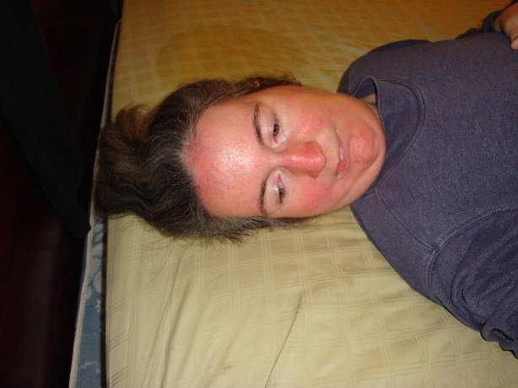

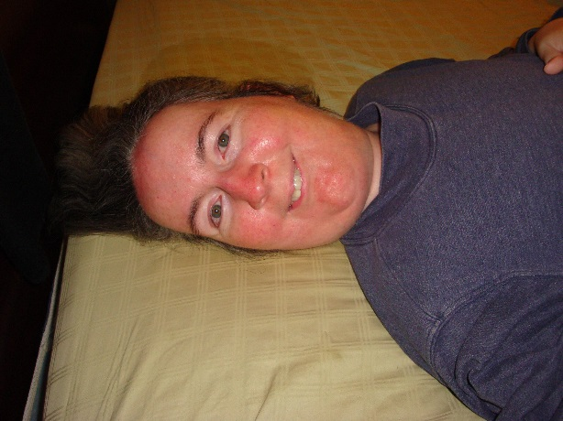

* Hands are best on my last rib:

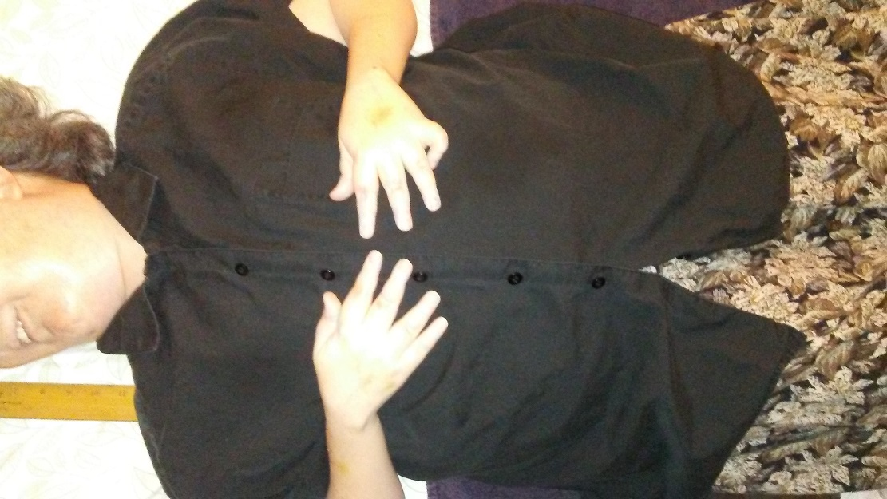

* To roll me over, bring right hand all the way down to my hip and left hand up. Make sure my fingers don’t get caught in buttons or under opposite arm:

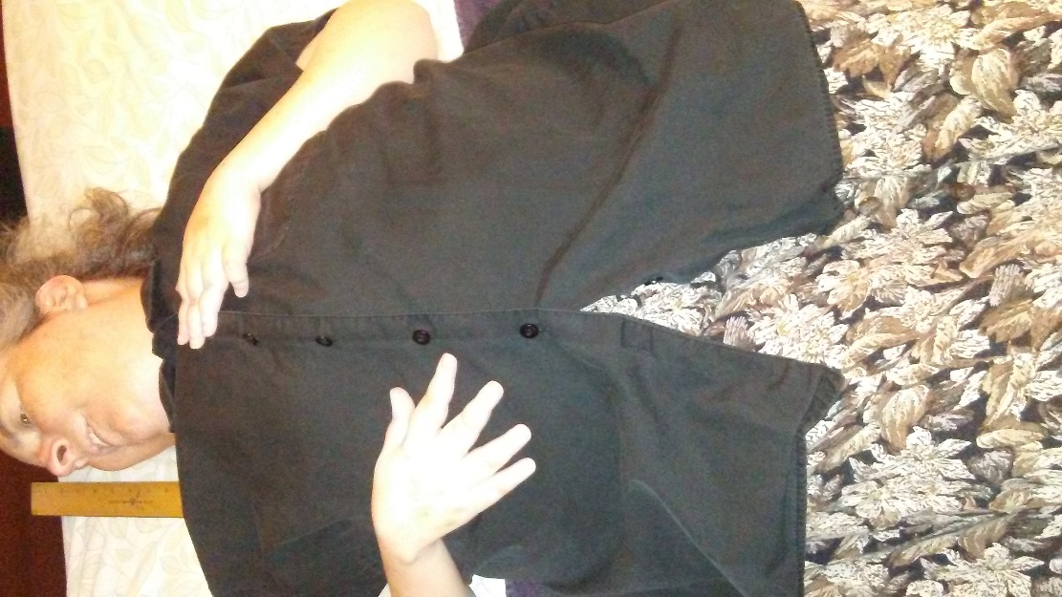

* Legs don’t open more than this:

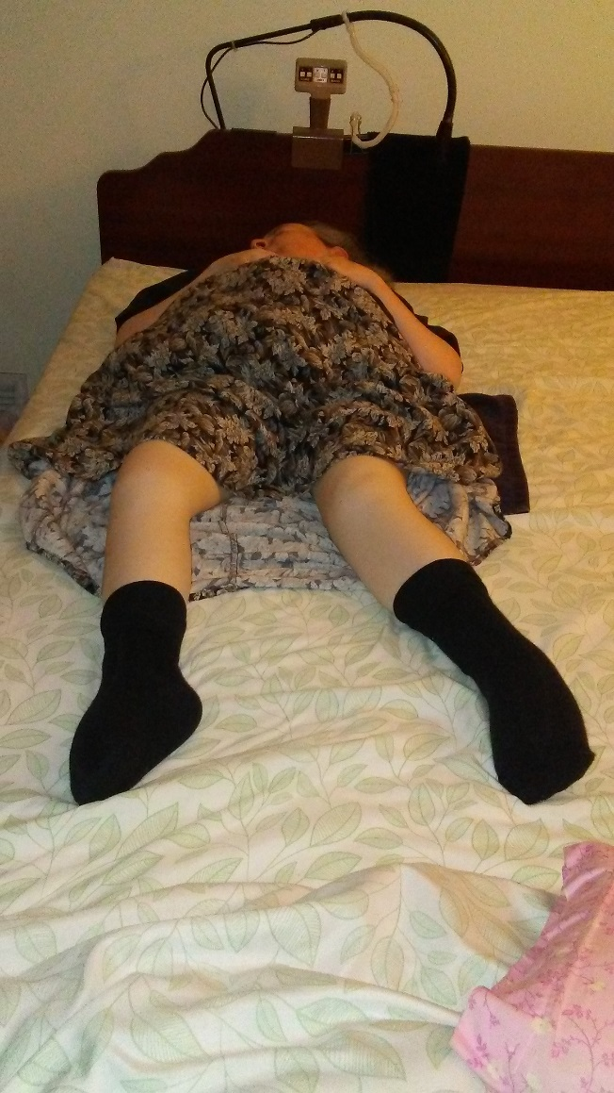

* Here is a good position for my legs:

